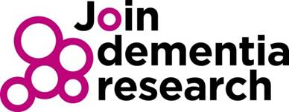

LEARN to help people Join Dementia Research

Join Dementia Research has helped more than 40,000 people connect with research studies over the past four years. As a result, researchers and their studies have massively benefitted with more than 11,000 study enrolments in this time.

However, if we are going to turn the corner and find ways to better prevent, diagnose, treat, care and beat the diseases that come with dementia, then more help is needed to support patients to become involved.

To raise awareness of how Join Dementia Research can help people with and without dementia, and the role healthcare professionals can play, the National Institute for Health Research has launched the LEARN Join Dementia Research awareness tool
This short online tool is aimed at anyone in health and social care who plays a role in caring for and supporting people with dementia, their carers and families. The process is simple:

- Watch a short film.
- Answer a few questions about what you’ve just seen.
- Find out ways you could help.
- Tell us a little about yourself.
- Receive your certificate.

Our Trust actively supports the delivery of research studies, and we are asking all staff to take a few moments to support this work and complete the process, using the link above.

Our aim is to ensure that everyone working in Trust knows what Join Dementia Research does and can simply and easily help people become involved.

Thank you for taking time to do this, and please do register yourself, as there may be a study for you too.

Thank you in advance. For any questions please contact admin.nddr@nihr.ac.uk

